Pass Task 18

Robust Rover

Related Learning Outcomes

**ULO1 – Explain the OO Principles**

**ULO2 – Use OO Language and Library**

The tasks demonstrates the use of C++ object-oriented programming language

**ULO3 – Design, Develop and Test using an IDE**

**ULO4 – Communicate using UML Diagrams**

**ULO5 – Describe Elements of Good OO Design**

IDE screenshots:

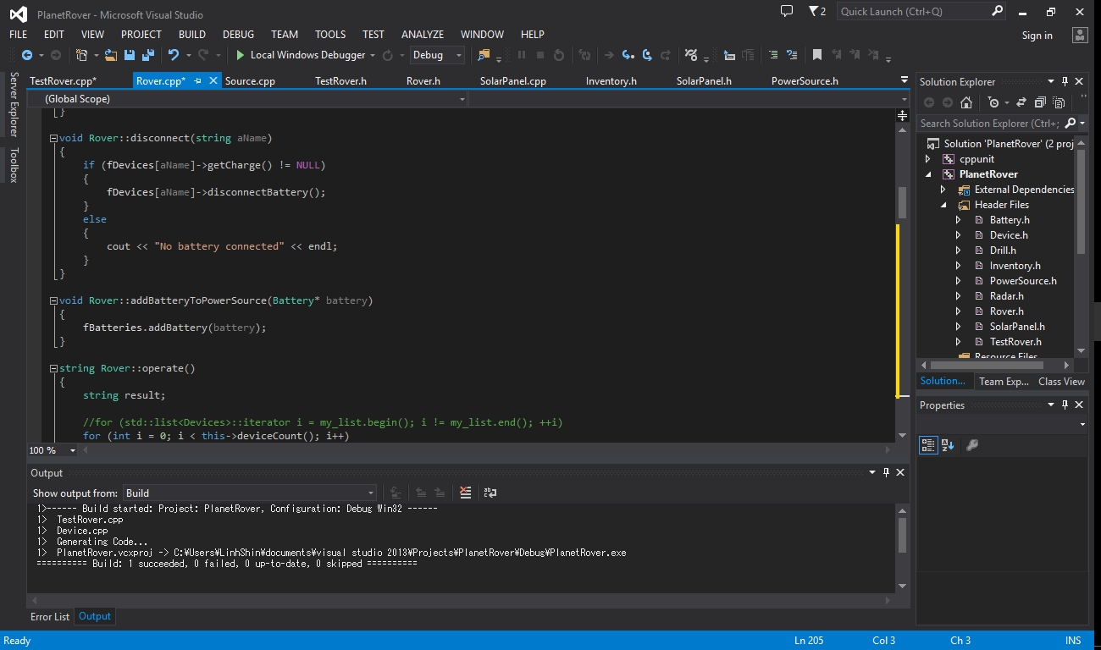

# CPPUNIT testing:

